Topic – Vehicle Loan System

Domain - Finance

Project Description:

Project Domain- Finance

Getting a loan is a very tiring and complicated process in India. It may take from weeks to months for loans to get approved and people have to visit the office again and again for documents and verification. This processing time can be reduced if we go for online solution of the same problem from bank as well as customer’s side. We would like to make end-toend loan cycle management. This will be helpful for all customer interaction with 360 degree view of customer across organization. With the implementation of this system we will have robust and real time analytics, customized reports and user specific layout. Also by implementing this we need not to worry to carry forward the data from local region to global regions.

The main functionality of this system will be check the requirement of the customer and after verification provide online loan as soon as possible and track user record.

Factors Affecting Car Loan EMI:

-Loan Amount: Amount borrowed by a borrower from bank. If you apply for a higher loan amount, your monthly EMI will be high.

-Interest Rate: It is rate charged by Bank on the vehicle loan. Higher interest rate increases your loan Emi which will increase total cost of loan.

-Loan Tenure: It is the period in which you can repay your loan to BANK. Longer loan tenure means lower car loan EMI.

Mandatory Modules and Description:

1.User:

Steps:

● Home:

The web homepage includes the login of user, if user is not registered then user will register first and the login into the website. Without login they can only access the basic information. ● User-Registration:

If User is new to website, then user can register himself and provide the necessary information. If user do not have any bank account, then too user can register. ● User-Login:

In Login page user will enter the login id and password to get the access to more information and user will be able to apply for the loan of his choice. ● Apply for loan:

In this page user can see the different schemas for loan and according to his preference and choice user can apply for the loan.

1. Admin

* + - Home:

The same web homepage includes the login of admin. ● Login Admin:

Admin can login by admin id and password. After login admin will be redirect to dashboard where admin can control all the action and verifies the document.

* + - Dashboard:

In dashboard admin can see all the details about user and their activity and track all the loan details. ● Verify:

If user upload any document, then admin is the person who can verify the data. After verifying admin will create the bank account for user.

1. Calculate EMI-

-Amount

-Duration

-Interest Rate

E= P*R[ ((1+R)^n)/ (((1+R)^n)-1)]

P: Principal Amount R: Rate of Interest per month n: Tenure of loan in months

E: EMI

After filling all the entries, calculator will calculate the EMI value. 4- Check Eligibility-

* 1. Get Eligibility-

User Need to give details of vehicle details, personal information details, income details etc to get eligibility for the loan.

* 1. Complete Application-

User will upload all the documents such as Aadhar card details, PAN card details, address proof, salary slip of last 6 month etc.

After this admin will verify whether to approve loan or not based on user details.

Sample Output Screen for reference:

# 1- Home Page

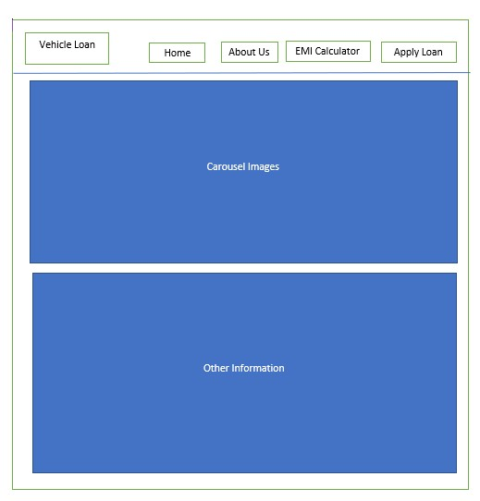

Fig 1: Homepage

Description: The Homepage consists of the Home, About Us, EMI Calculator and Apply Now. Below the Nav Bar, main highlights of the bank is shown. The Homepage also consists the footer.

# Get Eligibility

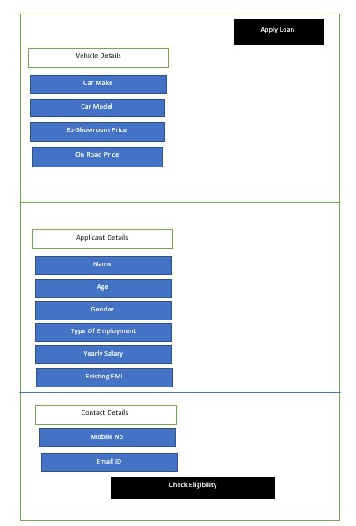

Fig 2a: Get Eligibility

Description: After the user clicks on Apply Loan, then the user will be redirected to get eligibility check page, where the user can check if he/she is eligible to apply for loan or not.

# 3.Loan Offer

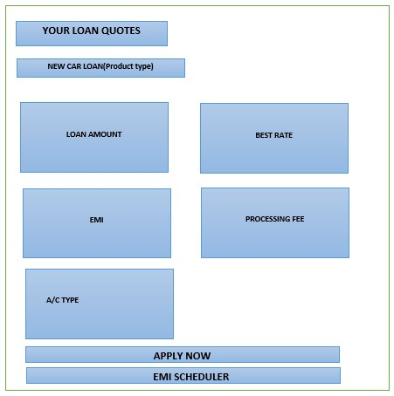

Fig 3a: Loan Offer

Description: If the user is eligible to apply for a loan, then he/she will be redirected to the Loan offer page, where he/she can decide on different Loan offers. When the user selects his preferred Loan offer, he can check for his EMI schedule, by clicking on the EMI scheduler.

# 3.Complete Application Form

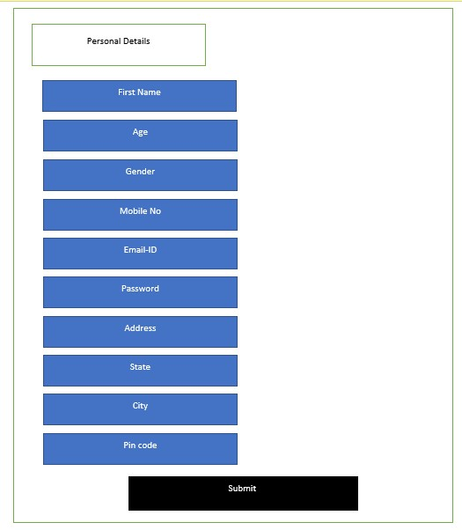

Fig 4a: Application Form page 1

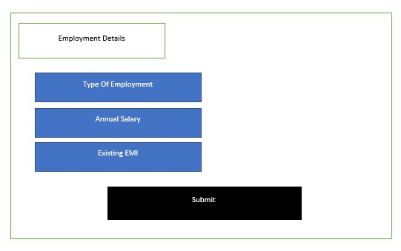

Fig 4b: Application Form page 2

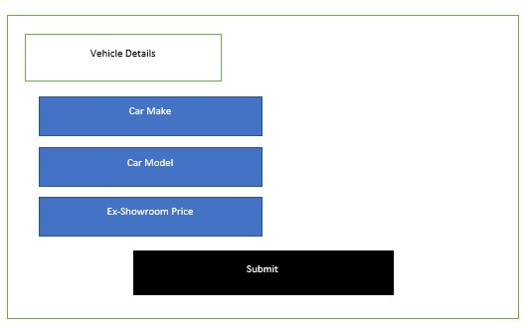

Fig 4c: Application Form page 3

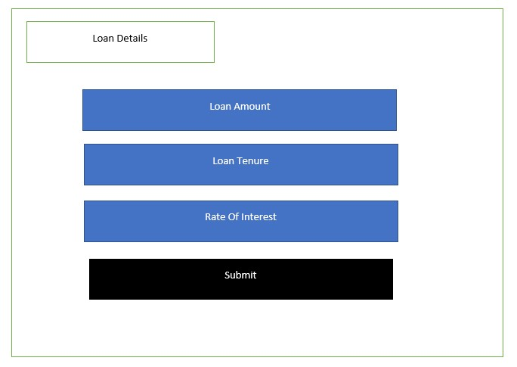

Fig 4d: Application Form page 4

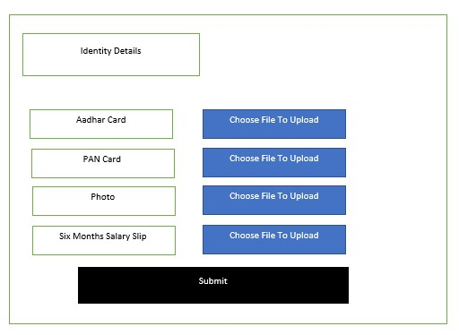

Fig 4e: Application Form page 5

Description: After the user decides on his preferred loan offer, he will be redirected to the complete application form. The user must fill all the details and this application form will be sent to the Admin for verification purpose.

# 5.User Login

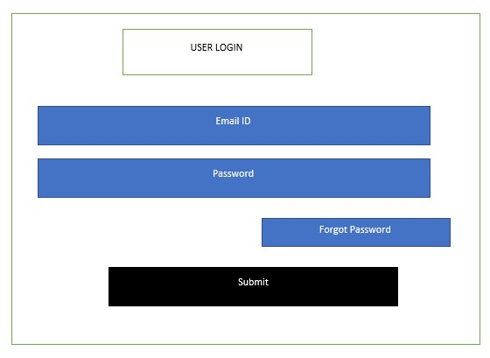

Fig 5a: User Login

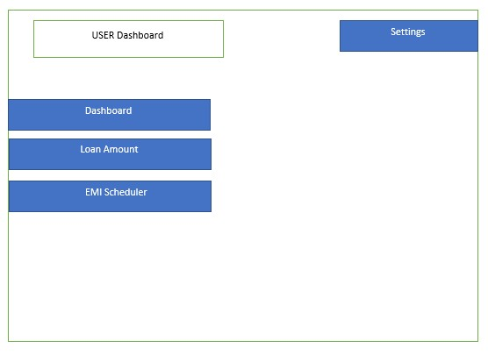

Fig 5b: User Dashboard

# 6.Admin Login

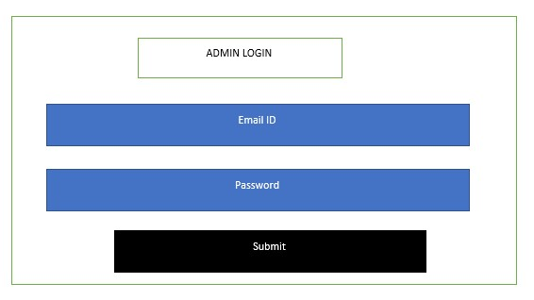

Fig 6a: Admin Login

Description: The admin login page consists of username and password. The admin must fill the details and click on Login.

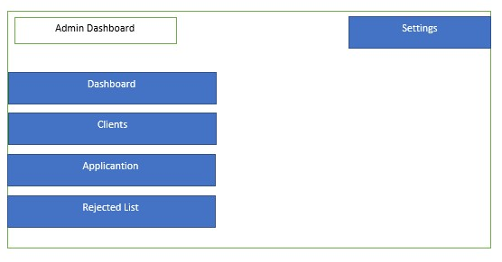

Fig 6b: Admin Login

Description: After the admin logs in on his account, he will be redirected to admin dashboard, where he can check for clients, new applicants, and users whose loan application are rejected.

Agile Methodology:

Abstract:

Agile development is a group of software development methodology based on iterative and incremental development, in which requirements and solutions evolve through collaboration between self-organizing, cross-functional teams.

Steps to follow in Agile methodology:

* You need to identify various user stories and its modules/tasks which needs to be implemented in the project as a part of Sprint planning.
* Divide all the user stories in two Sprints. Duration of each Sprint will be 3 days.
* Any backlogs of Sprint 1 should be included in Sprint 2 along with stories of Sprint 2.
* You need to prepare Scrum boards for each sprint. You can include both sprints in one scrum board if there is enough space for the same.

Instructions for writing scrum board:

* Chart papers, sketch pens, measurement scale and sticky notes will be provided for scrum board preparation.
* You need to decorate your scrum board well and it should be clean, visible and selfexplanatory.
* Discover a unique name for your project.
* Mention Group Number, TL and group member’s name in the scrum board.

Format for Scrum Board:

|  |  |  |  |  |  |  |
| --- | --- | --- | --- | --- | --- | --- |
| Your Project Name  Team Leader: <Name>   |  | | --- | |  |   Group Members: Logo, if any 1.  2.  3. | | | | | |
| User Story | TO DO | In Progress | Impediments | To Verify | Done |
|  |  |  |  |  |  |